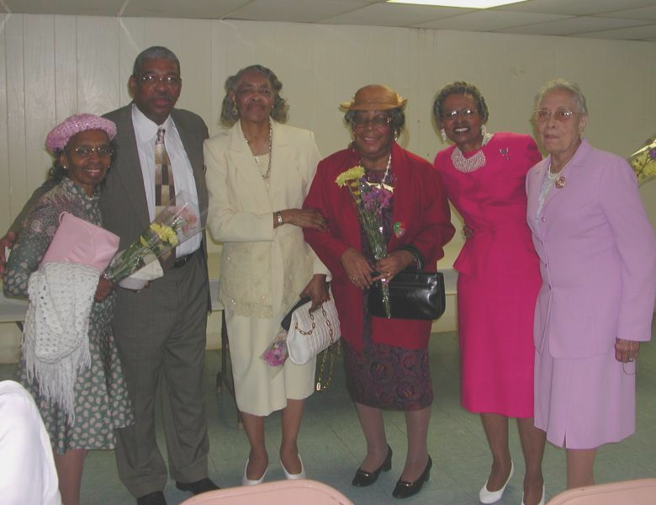

Camphor Memorial UMC
Vol. 3 No.3
Oct.-Nov, 2004

Rev. Reddick is joined by visitors for the dinner he provided for the Sick and Confined in September. Additional photos inside.

Fall: A time of renewal

Fall can seem more like the beginning of a new year than winter. It’s the crispness of the fresh air ushering us to start fresh, to begin anew. It’s the time of good weather, not too hot, not too cold. While the leaves are changing to the bright colors we so enjoy, our flowers are beginning their cycle, hiding their little buds away so that they may sprout again in spring. Fall is also a time to remember things past, such as when we were children and how great it was to start school with new clothes and new books, and to see friends again, some of whom we hadn’t seen all summer.

Fall is also a time of warmth. We begin thinking about Thanksgiving, and Christmas and family gatherings. It’s also a the time of warm revivals. But this year, we will not have revival services. So we will rededicate ourselves as we are through deliberate and focused attention to God’s word. And, we should do so as the collective body of Camphor Memorial United Methodist Church.

Rev. A. Roger Reddick, Camphor’s interim senior pastor, has begun Wednesday evening and Thursday morning bible study classes. The September teaching was on the Disciple as Believer. Rev. Reddick taught that a disciple is a learner an/or a follower of another person. A Christian disciple is a “believer in Jesus Christ who is striving to learn of Him, follow Him, and progressively become more like Him.” The lesson concluded that “a disciple is a believer, but a believer may not (always) be a disciple.”
This article is continued on the next page.
Our Pastor

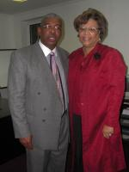
Rev. and Mrs. A. Roger Reddick.
1968, B.S. NCCU
1971, M.S. NCCU
1977, Duke Divinity School
1986, NCCU School of Law, JD
1998, Eastern Baptist Theological Seminary,
D. Min
Appointments:
7/1/2000, Trinity Chelten, Philadelphia
7/1/2004, Camphor Memorial, Philadelphia
Rev. Dr. A. Roger Reddick was appointed to Camphor on July 1. He is serving as interim pastor for one year.
Dr. Reddick has a bachelor of science, a masters of science, a juris doctorate, and a doctorate of ministry. He is a member of the North Carolina Central University (NCCU) Alumni Association, the Delaware County Parents Involved Network, the International Legal Fraternity PHI Delta PHI, and The MTV Conflict Resolution Education Network. A native of North Carolina, he is married to Sandra and they share three grown children and four grandchildren.
Dr. Reddick is the author of "The I and I Model for Overcoming Racism," which was inspired by his observing the courage displayed by South Africans when their leadership elected reconciliation with justice based upon biblical principles. Combining their ideas with his own, he created his model to overcome racism.

Renewal
Continued from page one.
The past few lessons have dealt with the soul, or the spirit, the part of us that will live on forever. As Christians, we believe that our souls, or our essence, will live on forever in heaven with the Lord. Among the 16-book reading list for this year’s Bible studies is “The Souls of Black Folk,” by W.E.B. DuBois, assigned to give us a better understanding of our essence.

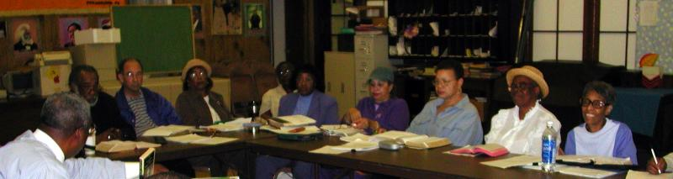
Rev. Reddick has taught that there are three parts of the Christian life: Believing, Belonging and Becoming. The scripture says, “From the very beginning, God decided that those who came to him should become like his Son” (Romans 8:29). While we are here on earth, we will never reach our fullest potential, no matter how hard we work. But, most of us can do better. In this time of renewal and revival, let us try to act on doing better; let us act on ‘becoming.’ -- Elaine Welles, Evangelism
Thursday evening bible study.

And … here we are
William Adams, and Mr. and Mrs. David Lawrence. Mrs. Essie Glover and Mrs. Judy Mellix.
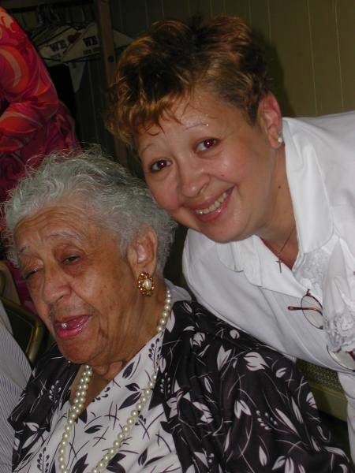
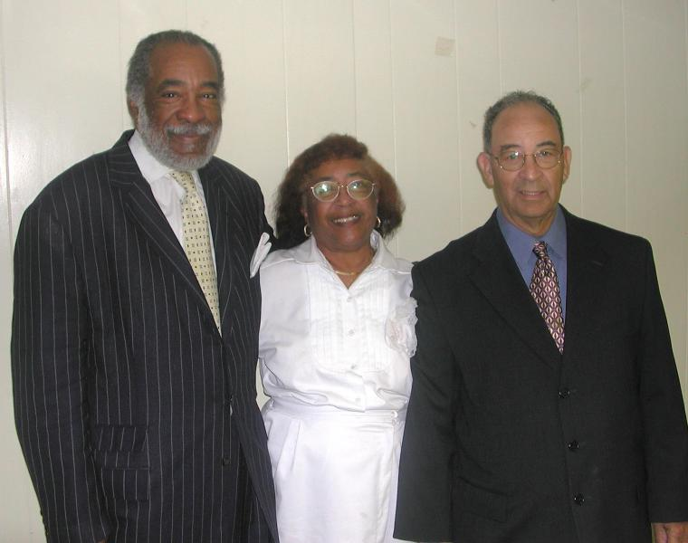

Sunday Fellowship
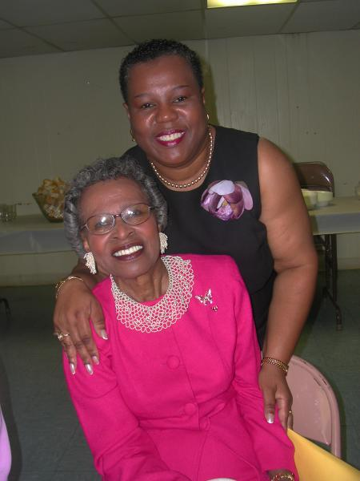
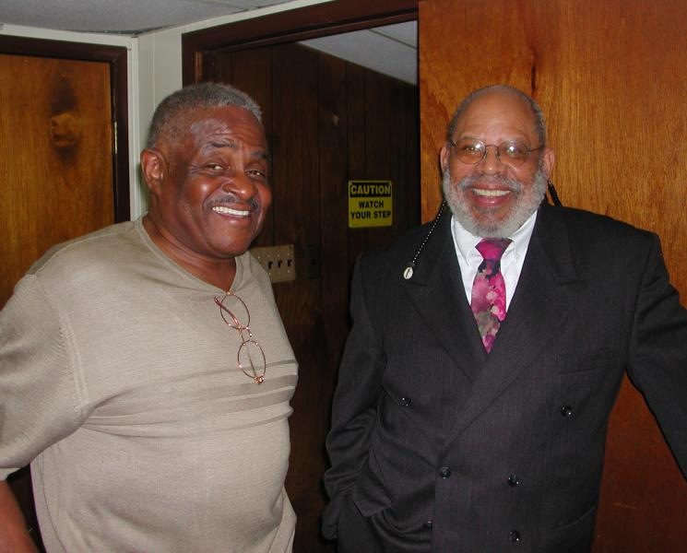
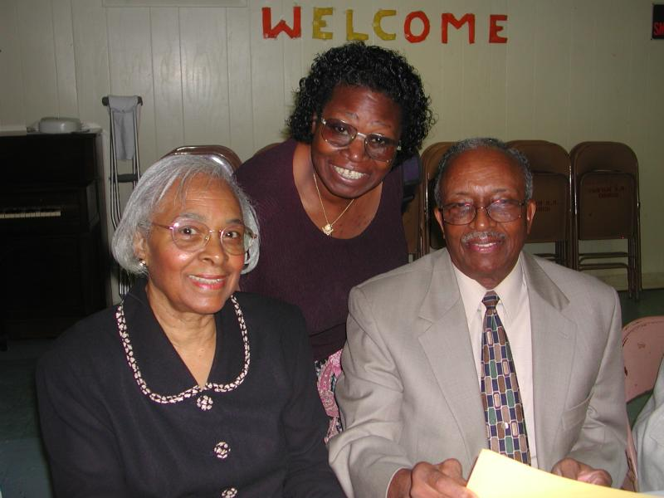
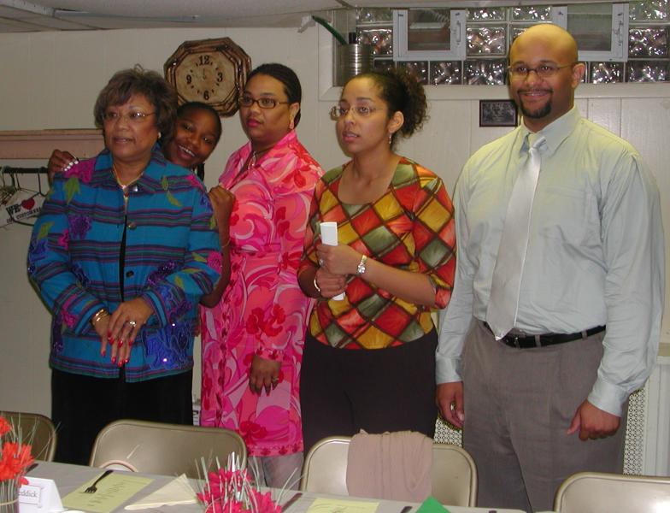
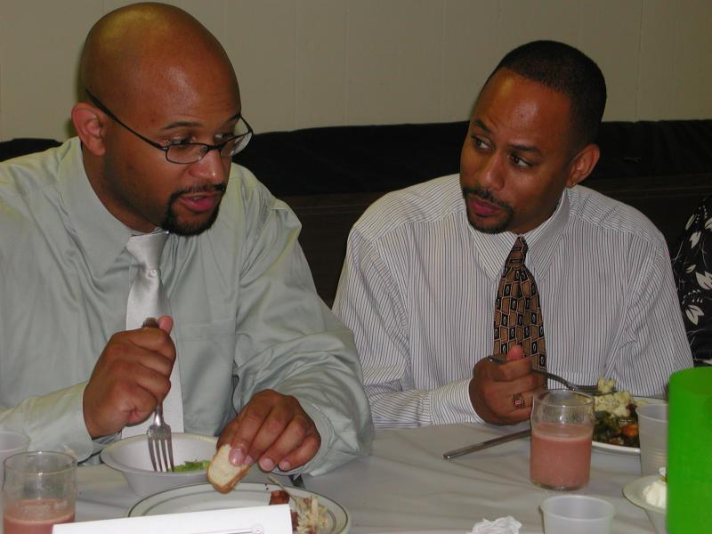
Carolyn Richardson (center) Joy Flynn and her Anthony Howard and
Revs. Ed Livingston and David Brown Mrs. Charlotte Dennis
Mrs. Reddick, her granddaughter Stephanie, and daughter Cheyla Olds; Revs. Emily and Ed Livingston. -- Photos by Carol Black
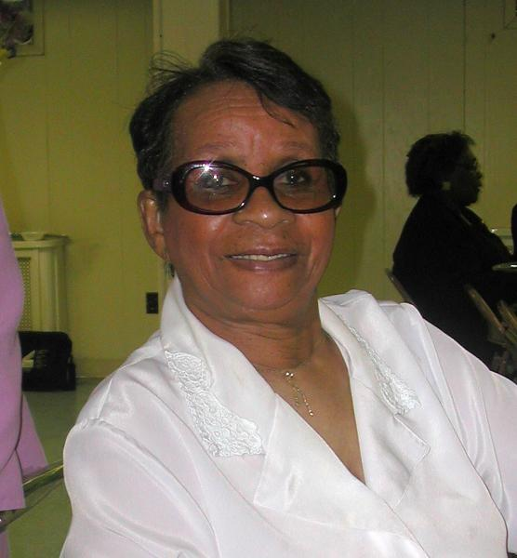
and Mr. and Mrs. Walter Stanley cousin, Mrs. Lillian Fields Reese Brown Sr.

‘The ministry Christ would have them do’

Methodism’s founder, John Wesley, was an Anglican priest in a rapidly growing, industrialized society made up of an elite upper class, a large lower class and a few in the middle. Seeing injustices, Wesley was not afraid to point to social flaws in England.

To this day, Wesley’s name remains among the 50 most important people in England.

The church’s Book of Discipline contains Social Principles adopted by each General Conference to address societal issues in a biblical and theological context. The preface to the Social Principles calls churches to “call to all members of The United Methodist Church to a prayerful, studied dialogue of faith and practice.”
Each local church is mandated by the Discipline to have a commission on church and society to bring to the congregation social and political issues that merit action or prayerful dialogue.

Faith Church in east Orlando, Fla. is known as a church that is active in the world.
“People think of us as ‘that big church,’ even though we’re little,” says the Rev. Deborah McKown, who has served the church for five years. Average attendance at its English- and Spanish-language worship services is 125.

The church has a voting ministry in which members act as poll workers. The voting ministry is also a tool for evangelism. “We know all our neighbors now,” McKown says.

Before school starts each fall, Faith Church holds a yard sale. As buyers prepare to pay for their items, they are handed a slip of paper reading, “This bill has been paid, just as Christ paid for your sins.”
Once a month, volunteers from Faith Church feed 300 to 500 of Orlando’s homeless. “We’re the smallest church that does that,” McKown says. She attributes the congregation’s activism to its blue-collar roots. “These people have known good times and difficult times.”
Helping others, she says, is the members’ way of assuming “the ministry Christ would have them do.”
This article by Diane Samms Rush was excerpted from the Sept. 2004 edition of the Interpreter Magazine.
Camphor Memorial
United Methodist Church
5620 Wyalusing Ave.
Philadelphia, PA 19131

Visit Camphor on the web at www.camphormemorial.org
We may not all believe exactly the same thing, but the people of the United Methodist Church believe in God and each other. If you’re searching for something to believe in, our hearts, our minds and our doors are always open.

