The

Camphor Light

Vol. 5, No. 2 February, 2005

INSIDE:

Around Camphor – page 3

In the Spotlight: Kurtis Todd – page 8

Pages from Camphor’s History – page 2

The Church Around the World – page 6

Youth Ministry at Camphor – page 5

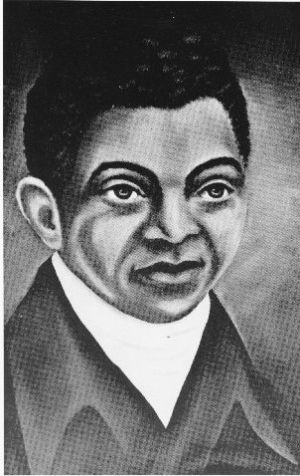

Celebration of
Black History Month

This special issue of Camphor Light celebrates “Black History Month” and looks back at some of the great Blacks in Methodism and great moments in the life of Camphor Memorial UMC (on page 2).

The insert drawing on the right is of Harry Hosier (1750-1806) who was born a slave in North Carolina. Following the Revolutionary War he gained his freedom from his Maryland master, and was converted to Methodism. His sermon, "The Barren Fig Tree," preached at Adam's Chapel, Fairfax County, Virginia, in May of 1781, was the first recorded Methodist sermon by an African-American.

Hosier became famous as a traveling evangelist up and down the Atlantic seaboard. He was a companion on evangelistic trips with Asbury, Coke, Jesse Lee, and Freeborn Garrettson, and was heralded as one of the greatest preachers of his time. His influence was one of the most important factors in the early spread of the Methodist Episcopal Church in America.
-Continued on page 4

Pastor's Message

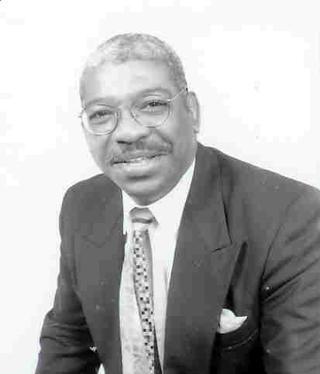
At the threshold of the 21st century, probably the most important question facing the pilgrim people called Afro-American is, will the Black church survive? This is not simply a rhetorical question; the church is the single most prominent and important institution in the Black community. It is both terrifying and challenging to realize that as the church goes, so goes the community, the nation, and in large measure, the world.
Afro-American church history helps us to recognize that there is a resident in the Afro-American community, a religious identity (a social, theological and biblical understanding) that tends to supersede denominational labels, ecclesiastical forms, or even geographic location. In this instance we can legitimately speak of the Black church.
I agree with C. Eric Lincoln when he contends that there is continuity between the Black church and the Black community precisely because the Afro-American experience and identity is molded and shaped by the powerful influence of the institutionalized Black church. I believe the Black church is a universal church, claiming and representing
-Continued on page 4

1925 | Six years on the District gives me some knowledge of the field, the man and the conditions under which they worked.... In my first five years, 6 missions were started, namely: New Rochelle; Trenton, Hamilton Memorial; Woodbine; Camphor Memorial; Grace. At Camphor, pastor, J. I. Peaco, received $100 for improvements and $925 for the church. Through the society, we are now completing the Camphor Memorial Church at 58th and Haverford Ave., Philadelphia. This is a stucco building with seating capacity for 200 upstairs and well-apportioned rooms downstairs for social and other religious activities. J. I. Peaco and his people have raised $1,000 for the building. ( J. T.Fletcher, D.S.)
1939 | N. W. Moore Jr. reports 33 accessions (J.T. Fletcher, D.S.). [Per Statistical Table, there were 270 members on roll]. Editor: This session of the Delaware Conference of the M.E. Church was adjourned pursuant to its unification with M.E. Church South and Methodist Protestant Church on April 26, 1939 and immediately reconvened as the Delaware Conference of the Methodist Church within the Central Jurisdiction.
1943 | Camphor Memorial with D. L. Rideout, as pastor, marches on to greater heights. We reported last year that a splendid new parsonage had been purchased. We are happy to report that this year the congregation, in September, will go into one of the finest churches in the Central Jurisdiction, a property purchased from the Fifth Presbyterian Church, only a block and a half from the church’s splendid location. With the backing of the Board of Mission and Church Extension and the City Missionary Society and the constant encouragement of the resident bishop, and supported by the District Superintendent, these loyal people, led by a pastor who would not be disheartened, overcame many obstacles to secure this excellent plant for $25,000 cash. The church has one of the most beautiful organs to be found anywhere, a splendid Sunday School building, two kitchens, a pastor’s study, several committee meeting rooms, and every conceivable equipment for doing the educational work of the church. In addition to the achievement of assuring the acquiring of this plant, the church reports all apportionments met in full and $2300 paid on old church and parsonage debts. Ministerial support $1,946 in full; General and Annual Conference Benevolences $204, other Conference obligations $196, Women’s Society $325, Current Expenses $1465. New Members added, 48. Camphor Memorial expects to entertain the next session of the Delaware Annual Conference. Camphor reported 382 active members. (J. W. Jewett, D.S.)
1951 | (C.D. Gerald). We have a wonderful congregation in Camphor. The membership is loyal. They love their church. As a result they have had a good year’s work. The pastor at the beginning of the year was somewhat physically indisposed. Rev. J. T. Fletcher assisted him with the church work until the pastor felt able to resume full responsibility. Additions to church membership 37. Total raised for World Service $343. Other Benevolence Askings $463. Total ministerial support $3776.00 Grand total raised for all causes $14,939.60. Per statistical tables, total full members 718 (L. S. Moore, D.S.)
1958 | Camphor Memorial (Philadelphia, PA) is noted for her excellent music, helpful worship services, and effective program of Christian education. The large regular attendance is inspiring. The church reports 46 conversions, 54 accessions, $916 for the Reserve Pension Fund, $850 for World Service and Conference Benevolences, paid if full, and a total of $25,214.00 raised for all purposes. This was a banner year for Camphor. With uprightness of character, spiritual stamina, and a shepherd’s heart, the Rev. Walter R. Stanley and the church have advanced with ‘esprit de corps’ and constant devotion to duty.(Walter R. Hazzard, D.S.)
1965 | Camphor has tutoring services for youth sponsored by the Philadelphia Tutorial Project. The church is open five days a week for activities and has a fully organized Boy Scout and Girl Scouting programs. An older adult group has been organized and is active in the life of the church. A $60,000 program has been launched for renovating the church and recreational hall. Sent to the Conference Treasurer, $7,022.50. Camphor reported 911 members. Editor: this was the final session of Delaware Annual Conference, which had lasted 101 years, per its liquidation on April 28, 1965 when Camphor and 20 other African-American congregations in the area became charges of the Philadelphia Annual Conference.

Camphor History…Select Years
From the pages of the former Delaware Annual Conference Journals (1925-1965)

Around Camphor Memorial UMC

•••Devotions are held every Sunday morning from 10 to 10:55 AM. Praise Team leaders are Ernestine Martin and Carol Black who uplift, worship and encourage through contemporary music, prayer, sharing of testimonies, Bible reading and inspirational messages. Come catch the Spirit!

••• A new Flower Club was formed February 9 to provide a second bouquet of flowers for Camphor’s altar. The new club has been placing flowers on the alter every Sunday since February 13. The members of the club are Janet Adeyami, Brenda Cozart Harris, Dorothy Tate, Jeanne Davenport, Paula Davenport, Edythe Lawrence and Betty Peyton.

•••Women’s Day will be celebrated on April 17, 2005 at 3 PM. Co-Chairpersons are Paula Davenport and Gloria Thompson.

•••An Adult Sunday School Class has been formed and meets 9:30 to 10:45 AM. Everyone welcome! Coffee and doughnuts are provided. Dr. Reddick is the teacher.

•••Our Sick & Shut-In. Members, please call the church office to report the name, address and telephone number of any hospitalized, ill or homebound members so they may be included in the Nurture Ministry.
••• The Diagnosis and Healing Ministry, conducted by Dr. Reddick, meets every Saturday from 9:30 to 11:30 AM. The sessions provide insight and help for understanding and resolving conflict.

•••The next “Camphor Light” will be a March/April issue. Articles should be submitted by March 15 for publication on March 27.

•••Good Friday Service will be held at Camphor on Friday, March 25, from 12 to 3 PM. The service will include the “Seven Last Words” and singing by “Chosen,” Camphor’s newest choir. A Family Unity Fish Fry dinner will follow the service. Donation for dinner is $5.

•••Easter Worship Service will be held Sunday, March 27 at 11 AM. The Sunrise Service will be held at 5:45 AM, followed by a Continental Breakfast.

••• Be a good steward and pick up your 2005 Giving Envelopes in the Great Hall. Your weekly tithes and offerings are necessary to support Camphor and meet our Conference obligations.

•••Gloria Johnson was featured in a Special Report “New Family Tree” that aired on WPVI-6 Action News on February 16 at 11 PM. Through DNA testing, Gloria was able to trace her father’s ancestry to the Obie people in Nigeria and her mother’s ancestry to a people in Cameroon, West Africa. The video story can be viewed online at Goria Johnson Video (http://abclocal.go.com/wpvi/news/021605_sr_familytree.html)

••• Rev. Ralph Blanks has been appointed by Bishop Marcus Matthews to the superintendency of our Central District effective July 1. Rev. Blanks will bring a wealth of experience to the Cabinet as pastor (Mother Zoar, Janes) and community advocate (Nehemiah Housing, Black Clergy of Philadelphia).

••• 2005 Annual Conference Workshops: The DNA of Small Membership Churches, Technology and the Local Church, Ministry of Finance-Building the Local Church Budget, Writing Successful Proposals and Grants, Healing the Wounds, Youth and Christ Servant Ministry-Where Do They Fit? Developing a Vision for Your Congregation, The Art of Developing Spiritual Gifts, Property Liability, Workers Comp and Risk Management, Emerging Trends and Demographics, and Charles Wesley, the Founder of Methodism. Plan to attend Sessions downtown at Loew’s Hotel, June 15-18!

Black History, cont’d

Richard Allen (1760-1831), the founder of the African Methodist Episcopal Church, was born a slave in Philadelphia. After purchasing his own freedom as a young man, he joined St. George's Methodist Church, from which in 1787 he led a dramatic withdrawal of black members. Allen soon became pastor of the group and was ordained as a deacon by Bishop Asbury. When the African Methodist Episcopal Church was organized nationally in 1816, Allen was consecrated its first Bishop.
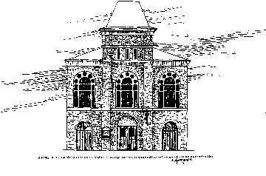
Zoar UMC is the oldest Black Methodist Congregation in America. After Richard Allen led most of the black members into the new A.M.E. denomination in 1787, some African-Americans remained in the St. George's congregation. Several years later, in 1794, eighteen of these members began holding their own religious services. They first met in homes; then in 1796 they purchased property and built African Zoar Church north of Philadelphia's city limits in a section called Campington. "Black Harry" Hosier is the church's patron founding pastor. The members of this new church never loosed their ties to the Methodist Episcopal Church, making Zoar the oldest black congregation in the United Methodist tradition with a continuous existence. Zoar was the fourth congregation in the United Methodist tradition to be organized in Philadelphia. Today Zoar and St. George's remain as the oldest United Methodist congregations in the city. Zoar Church's first black pastor was Perry Tilghman, a lay preacher who served the church from 1835 to 1844. At least five other congregations have been organized out of Zoar church, earning it the affectionate nickname "Mother Zoar."

Pastor’s Message, con’t

all Blacks out of a long tradition that looks back to the time when there was only the Black church to bear witness to “who” or “what” a man was as he stood at the bar of his community. The church still accepts a broad gauge responsibility for the Black community inside and outside its formal communion. However, God has replicated diversity on the shores of America. The institutionalized Black church must be open and inclusive. Failure to be receptive to change (a new thing that God is doing) could further erode its prominence and importance. Read Dr. Reddick’s book, The I and I Model for Overcoming Racism in an age of Diversity.

The Black church is the primary institution in America; therefore, it has been given a sacred stewardship trust to become all it can be as an instrument of God’s transforming Spirit. I believe every congregation needs a “picture” that is a contextualized understanding of it’s work in the world. The church might do well to recognize the fact that it deals with real people, in a particular location, with their collective sense of history and tradition.

My consciousness has been raised regarding the special work that the church in the city must perform through its particular roles as advocate (the prophetic function) as a nurturer (the priestly function). Indeed, Jesus of Nazareth challenges the church –including the Black church –to take up its role as prophet—advocate for the downtrodden and abused:
-Continued on page 6

Camphor Youth Ministry

Camphor Youth Lend a Helping Hand

Camphor’s young people have been busy giving their time and using their talents to help others. Whether it is serving dinners after church or helping in the library, the youth members of Camphor are always eager to lend a helping hand.
From November to December 2004, they conducted a hat and mitten drive that resulted in over 100 winter items being donated to the Methodist Home for Children. The giving spirit continued when they offered free Christmas gift-wrapping to
Camphor members and neighbors.

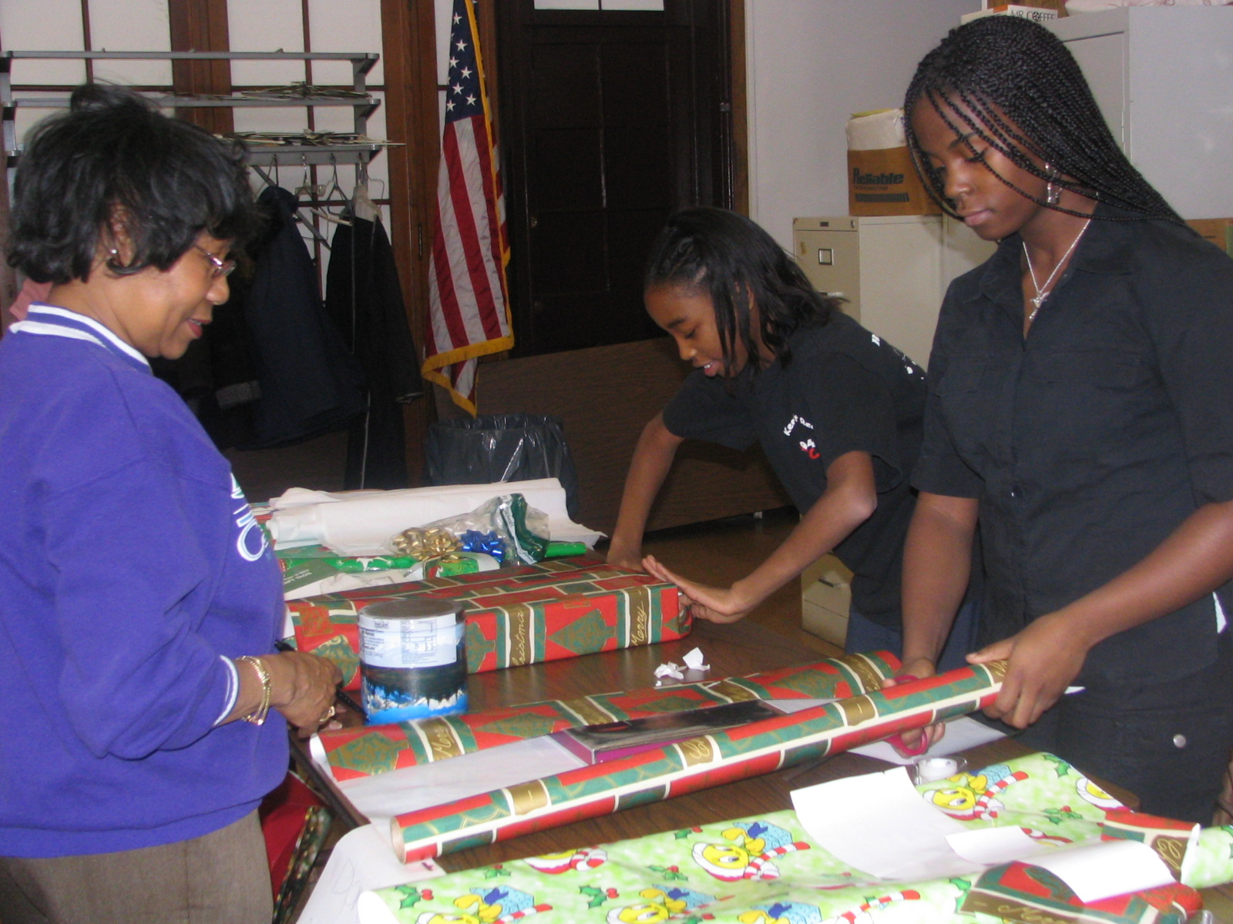

Tiffany Hundley and Kiana King wrap gifts for Mrs. Elaine Brown

On Martin Luther King Day,
18 members of the Youth Fellowship traveled to Agape Church in Norristown to assist the staff of their community development program run by Rev. Dr. William Robinson. Tasks included labeling library books, preparing a mass mailing, computer repair, data entry and creating photo displays.

“We had so much fun it didn’t feel like work,” commented Catherine Anthony after she helped to prepare a 500-piece mailing for Agape Church.
Tiffany Hundley felt “glad that we could help other kids with the hats and gloves.”
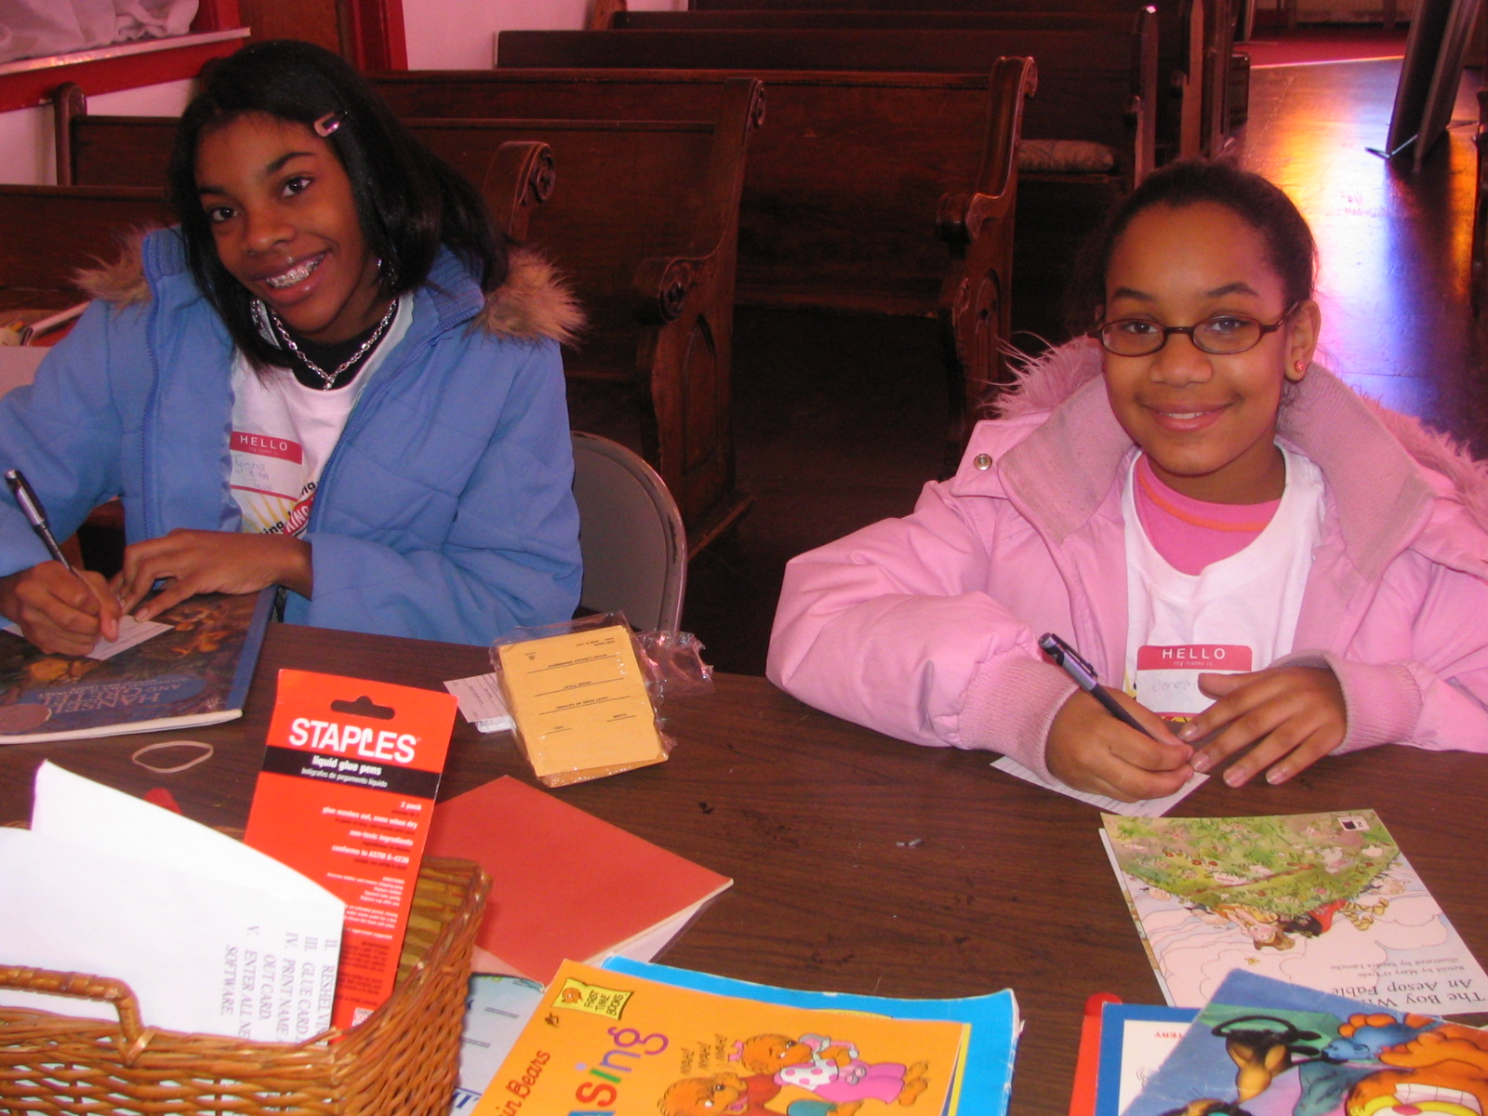

Tyisha Hundley and Candace Brown organize library materials

The group came up with the idea for the collection drive after learning there were children who would not have hats and gloves for the cold weather.

“Sometimes service finds you,”
added Devin Council. Everyone is eagerly awaiting his or her next opportunity for service.

Focus on YAC 2005
Youth Annual Conference 2005 is fast approaching and the excitement is building. If last year’s event is any indication, the youth groups that attend are in for a spirit-filled weekend.
Camphor youth are looking forward to attending the celebration to be held in May.

Candace Brown attended last year and says, “YAC gives us a chance to express ourselves.
We get to be with hundreds of other kids who love God and say it without being embarrassed.”
“We would like more kids to be able to attend this year,” says Rev. David Brown. “Sometimes it can be cost prohibitive. We hope to be able to find sponsors within our congregation to help.” The Youth Fellowship held two bake sales and expects to hold a car wash when the weather gets warm to raise more funds.
This year, Camphor youth have also been in on the planning of YAC. “There aren’t many African Americans there, so we want to make sure we are seen and heard,” says Kelly Rhem.
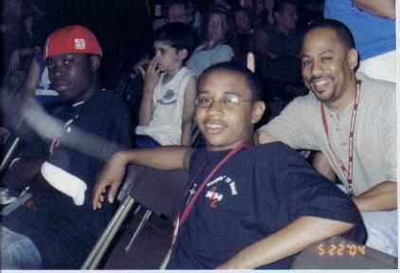

David Mingle, Terrell Thompson and Rev. Brown at YAC 2004
! Super Students !
Principal’s List

Catherine Anthony
Candace Brown
Tiffany Hundley
Tyisha Hundley

Honor Roll

Kelly Rhem
Keep up the good work!

Delegation forges ties with Indonesian church

The Church Around The World

NEW YORK — A United Methodist team’s visit to the island of Sumatra following the Dec. 26 tsunami has laid the foundation for a future partnership with Methodists in Indonesia. United Methodist Bishop Joel Martinez said he found Indonesian church leaders “genuinely pleased” about the Jan. 12-16 visit. Missions executive R. Randy Day, also on the trip, said he would like to see new aid directed to the care of internally displaced people now living in camps.

Contributions pass $4 million for tsunami relief

NEW YORK — Contributions to the United Methodist Committee on Relief for Asian tsunami relief passed the $4 million mark during the Martin Luther King Jr. holiday weekend. “We are still opening checks,” said Roland Fernandes, treasurer of the United Methodist Board of Global Ministries, parent organization of UMCOR.
Help is still needed. Donations to the “South Asia Emergency” relief effort can be placed in local church offering plates or sent directly to UMCOR, 475 Riverside Drive, Room 330, New York, NY 10115. Designate checks for UMCOR Advance #274305 and “South Asia Emergency.” Online donations can be made at www.methodistrelief.org. Those making credit-card donations can call (800) 554-8583. One hundred percent of the money donated to “South Asia Emergency” goes to the relief effort.

Pastor’s Message, con’t

“The Spirit of the Lord is upon me, because he has anointed me to preach good news to the poor. He has sent me to proclaim release to the captives and recovering of sight to the blind, to set at liberty those who are oppressed, to proclaim the acceptable year of the Lord.” Luke 4:18-19

The four big C’s of our day: Change, Complexity, Confusion and Conflict exist in the

Pastors take center stage at inaugural events

WASHINGTON — Two United Methodist pastors had prominent roles in events related to the inauguration of President George W. Bush. The Rev. Kirbyjon Caldwell, pastor of Windsor Village United Methodist Church in Houston, gave the benediction after the president’s inaugural address Jan. 20 – a task Caldwell also
performed in 2001. The Rev. Mark Craig, pastor of Highland Park Church in Dallas, preached at the Jan. 21 National Prayer Service attended by Bush and other leaders at Washington National Cathedral. Highland Park is the home church of George W. and Laura Bush.

CNN chooses Atlanta pastor for health program

ATLANTA — The Rev. Leigh Ann Raynor, senior pastor of Thomasville First United Methodist Church in the Atlanta area, is one of five people selected to participate in the “New You Revolution,” a CNN health news feature to help people get fit. Her progress will be charted and updated each week on CNN’s “American Morning” show.

Camphor UMC- First Korean Presbyterian Fellowship and Multi-Cultural Program
Sunday, April 24, 2005
At 3 PM at Camphor UMC

community. We are going through a period of
human history when change and complexity seem to feed on one another. We change in order to deal with complexity. But change only makes things more complex. No wonder we end up confused. Now is it surprising that conflict is on the rise? Confused people often end up at odds over the direction to take. My time at Camphor is short. What direction are you taking at Camphor?

--Rev. Dr. A. Roger Reddick

New Choir Formed At Camphor!

Around The Church, cont’d

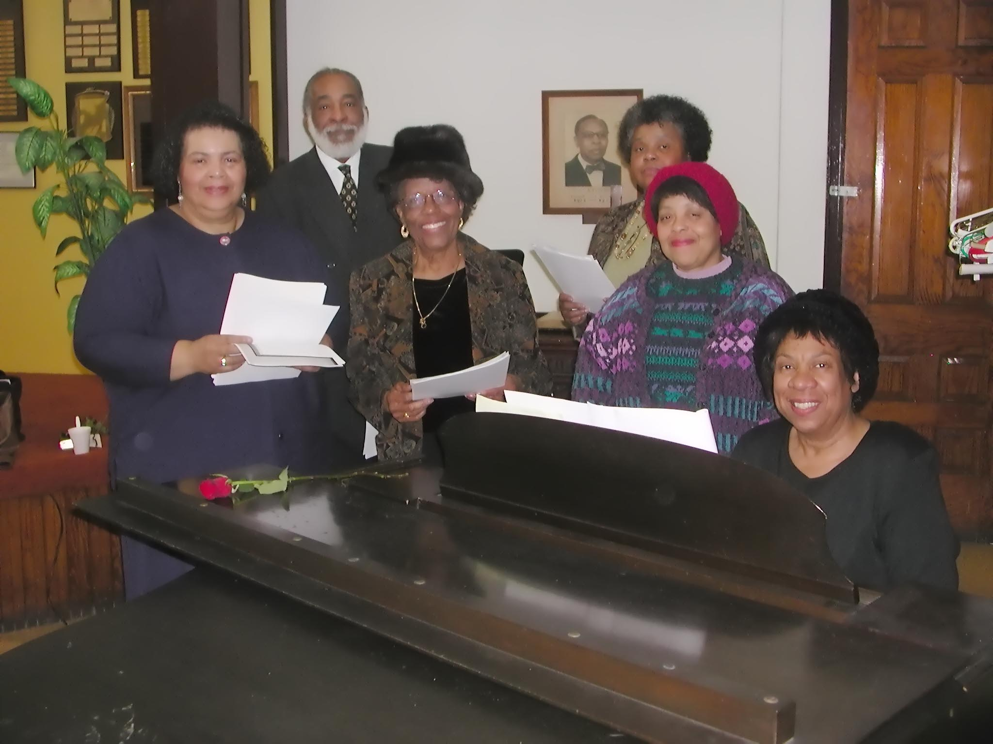

Members of Camphor’s newest choir, “Chosen,” are all smiles as they rehearse for the Good Friday Service at Camphor on March 25, 2005. Around the piano are Janice Washington, William Adams, Thelma Martin, Janet Chaffin, Jeanne Davenport, and Brenda Cozart Harris. Other members not in the photo are Carol Black, Dorothy Tate, Betty Rivers, Edythe Lawrence, Bettie Peyton and Anieta Duglas. Accompanists for “Chosen” are Brenda Cozart Harris and Howard Johnson, pianist/organist for the former Camphor Male Chorus. According to organizer, Janice Washington, “Chosen” was formed to sing the Lord’s praises and the Songs of Zion. The Choir’s Mission is grounded in Psalm 100 to “make a joyful noise unto the Lord; serve the Lord with gladness come before his presence with singing, enter into his gates with thanksgiving and into his sanctuary with praise, be thankful unto him and praise his name!” All are welcome to join!

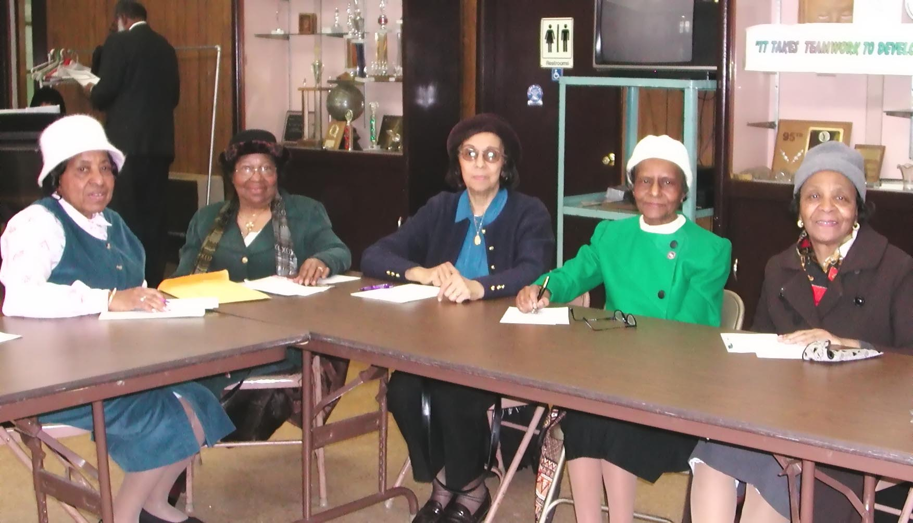
Members of the Camphor’s original Flower Club met at the church on February 20 to work on the Easter Lily Project. Around the table are Vivian Harmon, Jessie Graves (President), Gloria Pollitt, Marie Washington and Vernette McGuire

In the Spotlight…Kurtis D. Todd

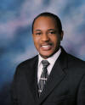
We salute Kurtis D. Todd, son of Mrs. Gloria Todd, this Black History Month, for his outstanding work as Chair of the Illinois Committee for Black Concerns in Higher Education (ICBCHE). In October, 2004, Curtis was the moving force for ICBCHE’s Annual Conference: "Unfinished Business: Rethinking Strategies to Achieve Brown v. Board of Education's Promise in Illinois," in collaboration with DePaul University, Chicago State University, the Illinois Board of Higher Education, The Illinois Council on College Attendance, The Illinois Association of Educational Opportunity Program Personnel, the Illinois Latino Council on Higher Education and Black Star Project.
A native Philadelphian, Kurtis graduated from Central H.S. and continued his undergraduate education at Amherst College with a concentration in chemistry/neuroscience. Additionally Kurtis graduated from Saint Joseph’s University with a degree in chemistry and continues his graduate work in Business Administration and Computer Science with a view toward a doctorate in Management Information Systems.
With vocal roots grounded from several years on Camphor’s church choirs, in Illinois, Kurtis joined the Calvary Memorial Church choir that recently debuted on the Christian television station, TLN (Total Living Network).
When asked what drives him to achieve, Kurtis replies, “Whatever our role or station in life, we are all here to serve God’s purpose. I go wherever God leads me, and if distracted or uncertain, I rest my mind on the reality that God is always in charge. The greatest gift we give to another is love, and what better way to share love than through the Gospel as demonstrated by our being. All glory and honor to Jesus Christ our Lord.”

Camphor Memorial
United Methodist Church
5620 Wyalusing Ave.
Philadelphia, PA 19131

Visit Camphor on the web at www.camphormemorial.org

We may not all believe exactly the same thing, but the people of the United Methodist Church believe in God and each other. If you’re searching for something to believe in, our hearts, our minds and our doors are always open.

Remember Our Sick & Shut-In

Mrs. Gladys Allen Simpson House, 2100 Belmont Ave., Phila., PA 19131
Mrs. Pauline Cunningham St. Ignatius Nursing Home #407, 4401 Haverford Ave., Phila., PA 9104
Mr. Pauline Carroll Tucker House Nursing Home, 10th and Wallace, Phila., PA 19123
Mr. William Covington 5627 Stewart Street, Phila., PA 19131
Mrs. Mae Daniel Simpson House, 2101 Belmont Ave., Phila., PA 19131; (215) 871-5366
Rev. Claude Edmonds 7701 Henry Ave., Apt D103, Phila., PA 19128
Mrs. Margaret Freeman Simpson House, # M330, 2101 Belmont Ave., Phila., PA 19131
Mrs. Mary-Lora Garvin 1853 Wynnewood Road, Phila., PA 19151
Mrs. Essie Glover 653 N. Frazier St., Phila., PA 19131; (215) 474-0312
Mrs. Ossie Hayward 621 N. Frazier St., Phila., PA 19131
Mrs. Zula Hampton 3848 Brown Street, Phila., PA 19104
Mrs. Alice Habershaw Britthaven Inc., 1016 Fletcher St., Wilkesboro, NC 28697
Mr. Lewis Hill 1101 N. 63rd Street, Phila., PA 19131
Mrs. Katherine Keeling 625 Thomasville Church Road, Mt. Gilead, NC 27306; (910) 439-6748
Mrs. Lucy Levere 5714 Cambridge Street, Phila., PA 19131; (215) 877-3251
Mrs. Elizabeth Manning The Chateau Nursing Home, 956 Railroad Ave., Bryn Mawr, PA 19010
Mr. James Manning Simpson House, 2100 Belmont Ave., Phila., PA 19131
Mr. Dennis McNeill St. Francis Country House, 1425 Lansdowne Ave., Room 303, Darby, PA 19023

Mrs. Dorothy Miller 6221 Washington Ave., Phila., PA 19143; (215) 471-3289
Mrs. Marjorie Mitchell 330 Main Street #204, Newark, DE 19711; (302) 234-8854
Mrs. Lula Mock Chateau Nursing & Rehab Center, 956 Railroad Ave., Bryn Mawr, PA 19010

Mr. & Mrs. Charlie Moore, Sr. 6107 Ellsworth Street, Phila., PA 19143; (215) 472-2251
Mrs. Ethel Moore 623 N. Frazier St., Phila., PA 19131; (215) 474-4524
Mrs. Terezin Richards 2100 Wanamaker Street, Phila., PA 19151
Mr. Ernest Sellers 220 N. Centre Street, Merchantvile, NJ 08109, (856) 488-1149
Mrs. Hilda Sheppard Presbyterian Home, 2100 S. 58th Street, Apt 362, Phila., PA 19143
Mrs. Naomi Waters 5512 Name Ave., Baltimore, MD 21215; (410) 358-2675
Mrs. Margaret White Hairston Hall, Flourtown, PA 19031

"I was sick and you looked after me." Matt. 25:36 (NIV)

Happy February Birthday!

Mrs. Joanne Brooks-Jones
Ms. Nicole Brown
Mr. Ronald Deas, Sr.
Mrs. Edith Drumgoole
Mrs. Ann Hargis
Mrs. Geraldine Lambert
Mr. Arthur Langford
Mrs. Lula Mock
Mr. Charlie Moore
Mr. Dennis McNeill
Mr. Clifton Officer
Mrs. Rosetta Stanley
Mrs. Naomi Waters
Mrs. Evelyn Woodson

Blessings to Our College Students!

Tiy Adams
Howard University Medical School

Melissa Alves
Howard University Law School

Daisha Harris
University of Pittsburgh

Brendan Harris
Johnson C. Smith University

Paul Jordan, Jr.
Morehouse College

Rev. Emily Livingston
Rev. Edward Livingston
Lutheran Seminary

Kenny McKnight
New York University

Victoria Mingle
Millersville University

Randie Welles
Barnard College

HH
H

In Memoriam

Rev. William Strother
Former Pastor of Camphor
December 26, 2004

Mr. Kermit C. Downes, Jr.
December 31, 2004

