Camphor Memorial United Methodist Church

Newsletter for January, 2005, No 1 Vol. 5

Around the Church
Church Conference
District Superintendent Rev. Phillip Ponce will return to Camphor on Tuesday, Feb. 1 at 7p.m. to complete unfinished business from last month’s Charge Conference. At the December meeting, Rev. Reddick’s salary was approved and a budget for 2005 was accepted.

Rev. Dr. Frederick Douglass thanked individuals and groups that had contributed to the Methodist Home for Children, including the Rev. David and Sharon Brown and the Youth of Camphor, who contributed hats and mittens to children of the home.

Circle Outreach, a group of ladies primarily from Camphor, took household items and clothing to residents of The Bridge, on the Methodist Home campus. The recipients were women transitioning into permanent housing. Circle Outreach activities also include providing a scholarship each year and contributing to five organizations, including the NAACP and the YWCA.

Reese Brown Sr., Ruth Harmon and Walter King were acknowledged as the church’s Christ Servant Ministers for which they have been certified by the Conference. They may participate in various ministries of the church and conduct bible study. Their certificates must be renewed every three years.

And a celebration
Ruth Harmon officially retired form the School District of Philadelphia on June 30, 2004 after 38 years of service. She had been a reading specialist and a Reading Recovery teacher. Her retirement celebration was on Nov. 5 at the Drexelbrook Banquet Facility.

Around the Conference
New Appointment
 Bishop Marcus Matthews announced the appointment of the Reverend Ralph Blanks as superintendent of the Central District, effective July 1, 2005.

Annual Conference
The Annual Conference will open with a midday worship service on Wednesday, June 15 and will be held at the Loews Hotel, 12th and Market streets in Philadelphia. The conference will include evening business sessions and will adjourn with an Ordination Service Friday evening, June 17, at nearby Arch Street UMC. The Laity Sessions will be held at a separate location. EPA's 2005 Clergy Session will be held at Hempfield United Methodist Church on Monday, June 13, 1 to 4 p.m. The Church is located at 3050 Marietta Avenue, Lancaster, PA. Keep the Commission on Conference Sessions in your prayers as coordinators continue to plan for a quality, spirit-filled, and inspirational residential holy conferencing.

Week of Prayer
United Methodists are invited to join with Christians around the world in a week of prayer for peace. Congregations are encouraged to set aside Jan. 18-25 to participate in the annual Week of Prayer for Christian Unity. The theme for the 2005 observance is "All Things are Yours… You Belong in Christ… and Christ, the Unique Foundation, Belongs to God," reflecting Paul's letter to the church at Corinth in 1 Corinthians 3:1-23.

Correction:
Charlotte Jones was incorrectly identified in the October/November newsletter. We apologize for the error.

Rev. Dr. A. Roger Reddick, Senior Pastor, Camphor Memorial United Methodist Church
5620 Wyalusing Avenue, Philadelphia, Pa. 19131 -- 215-747-2600
Page 2, Camphor News, Jan. 2005

Sick and Homebound

Mrs. Gladys Allen  Simpson House  2100 Belmont Ave.  Philadelphia, PA 19131  Mrs. Mary-Lora Garvin  1853 Wynnewood Rd.  Philadelphia, PA 19151  Mrs. Ossie Hayward  621 N. Frazier St.  Philadelphia, PA. 19131  Mrs. Elizabeth Manning  The Chateau Nursing Home  956 Railroad Ave.  Bryn Mawr, PA 19010  Mr. James Manning  Simpson House  2100 Belmont Ave.  Philadelphia, PA 19131  Mrs. Dorothy Miller  6221 Washington Ave.  Philadelphia, PA 19143  Mrs. Hilda Sheppard  Presbyterian Home  2100 S. 58th St., Apt. 362  Philadelphia, PA 19143  Mr. Lewis Hill  301 N. 63rd St.  Philadelphia, PA 19131 | Mrs. Pauline Cunningham  St. Ignatius Nursing Home #407  4401 Haverford Ave.  Philadelphia, PA 19104  Mrs. Essie Glover  653 N. Frazier St.  Philadelphia, PA 19131  Mrs. Zula Hampton  3848 Brown St.  Philadelphia, PA 19104  Alice Habershaw  Britthaven Inc.  1016 Fletcher St.  Wilkesboro, NC 28697  Mr. Dennis McNeill  St. Francis Country House  1415 Lansdowne Ave.  Room 303  Darby, PA 19023  Mrs. Margaret White  Hairston Hall  Flourtown, PA 19031  Rev. Claude Edmonds  7701 Henry Ave., Apt. D103  Philadelphia, PA 19128 | Mrs. Pauline Carroll  Tucker House Nursing Home  10th and Wallace Sts.  Philadelphia, PA 19123  Mrs. Margaret Freeman  Simpson House Apt. M30  2101 Belmont Ave.  Philadelphia, PA 19131  Ms. Lula Mock  Chateau Nursing and Rehab Center  956 Railroad Dr.  Bryn Mawr, PA 19010  Mrs. Marjorie Mitchell  3901 Conshohocken Ave.  Apt. 2211  Philadelphia, PA 19131  Mrs. Naomi Waters  5512 Name Ave.  Baltimore, MD 21215-4323  Mr. William Covington  5627 Stewart St.  Philadelphia, PA 19131-3405  Charles Moore  6107 Ellsworth St.  Philadelphia, PA 19143
I was sick and you looked after me." Matt. 25:36 (NIV)
Bible Verse: Matthew 25: 31-36

“When the Son of Man comes as King, and all the angels with him, he will sit on his royal throne, 32 and all of the earth’s people will be gathered before him. Then he will divide them into two groups, just as a shepherd separates the sheep from the goats: 33 he will put the sheep at his right and the goats at his left. 34 Then the King will say to the people on his right, ‘You that are blessed by my Father: come! Come and receive the kingdom which has been prepared for you ever since the creation of the world. 35 I was hungry and you fed me, thirsty and you gave me drink; I was a stranger and you received me in your homes, 36 naked and you clothed me; I was sick and you took care of me, in prison and you visited me. (Good News).

Page 3, Camphor News, Jan. 2005

Keeping up with the Youth at Camphor Church -- by Sharon Brown

Keeping up with today’s youth is no easy task. They are constantly on the move while exploring the world around them and members of Camphor’s Methodist Youth Fellowship are no different.

For several years, as Camphor’s youth grew older, graduated and moved on, the Methodist Youth Fellowship (MYF) became inactive. Former members of all ages still reminisce about skating and bowling parties, trips to Kings Dominion in Virginia, Youth Annual Conference and many more activities.

“When we heard about all of the fun things that other Camphor kids got to do, we wanted that, too,” said Kelly Rhem, MYF president. The ‘new’ Camphor MYF has been active for almost three years and has in that time doubled in membership.

“We try to plan fun things like taking trips or just hanging out,” says MYF vice president Lauren Brown. The group usually meets twice a month at the church. Meetings include a meal and discussion session led by
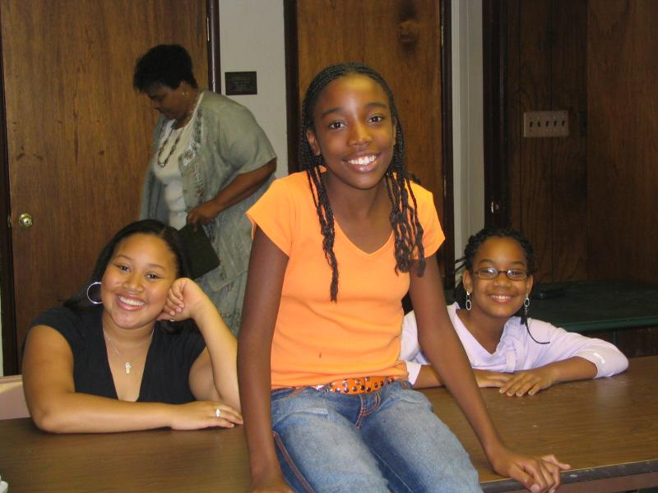
Rev. David Brown, where the kids can share their experiences and relate to one another. Any issues or concerns are dealt with from a Christian perspective.

“Most of the time they have solutions for each other if there is a problem that someone needs help with,” says Rev. Brown. The bible, role-playing, skits and games are tools that are used during the meetings. “The MYF allows the kids to see that they can have God in their lives and have fun, too.”

Methodist Youth Fellowship activities have included a snow tubing trip, movie nights, a day trip to Wildwood, holiday parties, Youth Annual Conference and youth activities at neighboring churches. Two members also attended a three-day college tour sponsored by St. Paul’s Baptist Church.

In order to finance their activities, the MYF has run several successful fundraisers -- a spring car wash, ‘Praise-a-thon’ and a bake sale. They also lent financial support to special church projects and held a winter hat and mitten drive for the Methodist Home for Children.

This year, the MYF is planning for more opportunities to fellowship with other youth through their ‘bring a friend’ program and by attending Christian youth programs in the Philadelphia area. “We like being at Camphor and want more kids to come,” says Kelly. “Most of us have family here and we want to keep the church going.”

Pictured, Sunday school students wait for the annual Sunday School Pancake Breakfast 2004.

Young Adults Recruited
The United Methodist Board of Global Ministries is recruiting young adults for its mission intern and US 2 programs in 2005. Application deadline for both programs is Feb. 1. The age range is 20 to 30 years old. Both programs emphasize leadership development and focus on spirituality as it relates to social justice in today's society. Young adults live with and learn from communities that struggle with injustice. More information is available at http://gbgm-umc.org/who_we_are/mp, the board's mission personnel website. Applications are available online or by contacting the Young Adult Program Office at (212) 870 3660 or sending an e-mail to MIRYAP1@gbgm-umc.org.

Page 4, Camphor News, Jan. 2005

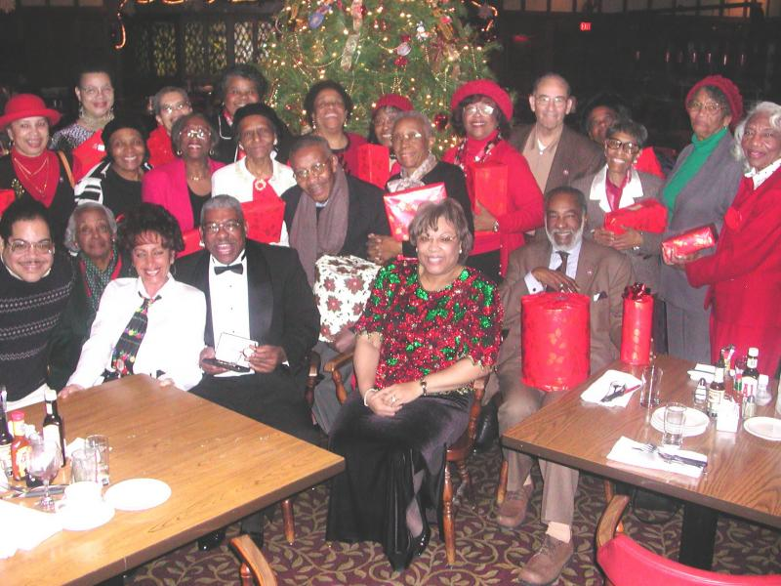
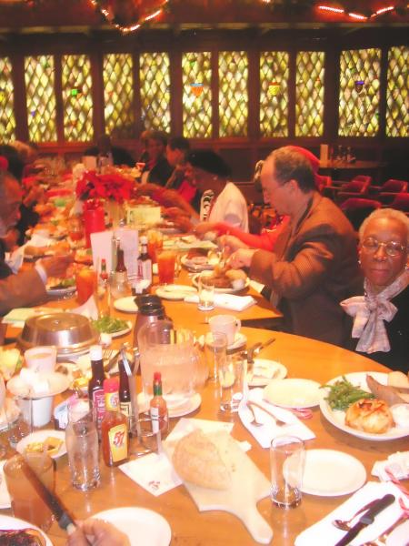

Members of the Bible study classes and others shared a festive good time with Rev. and Mrs. Reddick at Camphor’s Christmas dinner held at the Pub in South Jersey. -- Photos by Carol Black

News
Rev. Dr. Leah Gaskin Fitchue was inaugurated as the 16th president of Payne Theological Seminary in Wilberforce, Ohio, on Wednesday, November 10. Dr. Fitchue is the first African-American female president of any institution in the 244-member Association of Theological Schools, and the first female president of any historically Black theological school.

Dr. Fitchue is an ordained Itinerant Elder in the A.M.E. Church where she has served as Associate Minister at Mother Bethel A.M.E. Church, Philadelphia, PA, Jones Tabernacle A.M.E. Church, Philadelphia, PA, and Mt. Zion A.M.E. Church, Trenton, NJ. She is the daughter of Rosie Lee Jones, Newark, NJ and the mother of Ebony Joy Fitchue, Philadelphia, PA. Dr. Fitchue and her daughter are poets.

Television Programming of Interest
Slavery And The Making Of America, airing on WHYY-TV12 beginning Wednesday, Feb. 9, is a four-part series documenting the history of American slavery from its beginnings in the British colonies to its end in the Southern states and the years of post-Civil War Reconstruction. Drawing on a wealth of recent scholarship, it looks at slavery as an integral part of a developing nation, challenging the long held notion that slavery was exclusively a Southern enterprise. At the same time, by focusing on the remarkable stories of individual slaves, it offers new perspectives on the slave experience and testifies to the active role that Africans and African Americans took in surviving their bondage and shaping their own lives.

The first were bought in 1619, the last freed in 1865. In the intervening 250 years, slaves labored to make American what it is today.

The Congregation
WHYY will hold a free screening and discussion of the PBS documentary “The Congregation” on Wednesday, Jan. 26, beginning at 6:30 p.m. The program profiles a dramatic year in the life of the First United Methodist Church of Germantown during a time of profound change. Former associate pastor Beth Stroud will be the special guest. Kenwyn K. Smith, PhD, associate professor of organizational behavior at the University of Pennsylvania, will moderate audience discussion and Q&A. “The Congregation” will be rebroadcast on Sunday, Jan. 30 at 7 p.m. RSVP for the discussion by Jan. 24 at 215-351-1260. WHYY is located at 150 N. 6th St.
Top of Form 1
Bottom of Form 1

