Camphor Memorial UMC
Family and Friends Church Retreat

At the beautiful

National Christian Conference Center
1485 Valley Forge Road ~ Valley Forge, PA

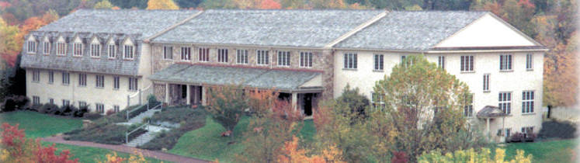

June 20 - 21, 2008

“Working Together in Christ”
Speaker: Rev. Evelyn Kent Clark
Limited reservations – See Registration Form for convenient payment information
Check in: Friday 3:00 p.m.
Check out: Saturday 5:00 p.m.

Cost: Double - $117.00
Triple - $102.00

- Three meals included - dinner, breakfast, lunch
- Handicapped accessible
- Meeting rooms
- Check must accompany registration

